Memorandum on combating ageism
and bridging the generation gap

October 2024

Summary: This paper provides a policy proposal to combat ageism and bridge the generation gap. It includes actions on education, social initiatives, and legislation in order to create a society free of age discrimination.

Ageism, also known as age discrimination, is a pervasive issue affecting individuals across all age groups. It manifests in stereotypes, prejudices, and discriminatory practices that marginalize both young and old, eroding social cohesion and perpetuating harmful norms. The consequences of ageism are far-reaching, affecting not only personal identity and social relations, but also the opportunities and resources available to individuals.

This document presents a comprehensive policy proposal to combat ageism and bridge the generation gap. It includes concrete actions and strategies that can be implemented within the education system, starting with pre-school education, and extending to broader social initiatives. By instilling values of respect, empathy and understanding in all age groups, we can promote a more inclusive and harmonious society, while maintaining a healthy social fabric.

The policies outlined in this proposal aim to:
- Educate children about the value and contribution of all age groups.
- Combat ageism at its root, tackling stereotypes and prejudices.
- Promote understanding and cooperation between generations to strengthen social cohesion.

1. Introduction

1.1 Understanding ageism
Ageism, or ageism, is a form of discrimination that involves negative stereotypes, prejudices and discriminatory actions against people based on their age. It affects people of all ages, but is particularly prevalent against older people and, to a lesser extent, young people. Ageism can manifest itself in a number of ways, such as social exclusion, discrimination in the workplace and unequal access to healthcare and services. These forms of discrimination can have a profound psychological, social and economic impact on individuals and society as a whole.

1.2 The importance of primary education in combating ageism
Children are particularly sensitive to impressions and the attitudes and beliefs they develop during their childhood can have long-lasting effects. Primary education provides a critical opportunity to shape these attitudes and challenge the stereotypes and prejudices that contribute to ageism. By instilling values of respect, empathy and understanding from an early age, we can lay the foundations for a society that values all its members, regardless of age.

1.3 Bridging the generation gap
The generation gap refers to the social, cultural, and economic differences between different age groups, especially between young and old. This gap can lead to misunderstandings, lack of communication and even intergenerational conflicts. Bridging this gap is essential to create a cohesive society where all age groups can co-exist in harmony and contribute to the common good. Education plays a key role in promoting understanding and cooperation between generations, which can help reduce ageism and create stronger communities.

2. Policies and actions to combat ageism starting with children

2.1 Integrating age exclusion awareness into the school curriculum
A crucial first step in the fight against ageism is to integrate awareness of ageism into the school curriculum. This includes teaching children about the diversity of age experiences, the value of all age groups, and the negative effects of ageism.

Development of a training programme
Work with educational experts and stakeholders to develop a comprehensive educational programme that includes age-sensitivity awareness as a key component. This programme should cover topics such as the biological, psychological, and social aspects of ageing, the contribution of older people to society and the harmful effects of age-based stereotypes and discrimination.

Ageism in history and literature
Incorporate a lesson that examines how ageism has been presented in history and literature. This may include studying the treatment of older people in different historical periods, as well as analysing how age-related issues are presented in literature and media.

Interactive learning modules
Develop interactive learning modules that allow students to engage with ageism in a practical way. For example, simulations or role-playing exercises can help students to experience what it might be like to be an older adult facing ageism.

2.2 Training and empowerment of teachers
Teachers and tutors are at the forefront of the fight against ageism in the classroom. Providing them with the necessary training and resources is essential to ensure that they can teach effectively and model age-inclusive attitudes.

Professional development programmes
Implementing professional development programmes that focus on raising awareness of ageism and intergenerational sensitivity. These programmes should equip teachers with the knowledge and tools to recognise and address ageism in their teaching practices.

Allocation of resources
Providing teachers with age-appropriate teaching materials, including lesson plans, books and multimedia resources, that promote positive attitudes towards ageing and intergenerational cooperation.

Advice and peer support
Establish mentoring programmes where experienced teachers can guide and support their colleagues in implementing age awareness activities in the classroom and in extra-curricular activities.

2.3 Promoting intergenerational learning and cooperation
Intergenerational learning provides an opportunity for different age groups to interact, share knowledge and develop mutual respect. Schools can serve as a platform to facilitate these interactions, helping to bridge the intergenerational gap.

Intergenerational guidance programmes
Creating programmes where older adults mentor students in various subjects, e.g. history, arts, maths, etc. These programs can be particularly effective in subjects where life experience, whether professional or personal, adds valuable perspective.

Cooperative projects
Developing school projects that require collaboration between students and older people. These could include oral interviews, community service activities or joint creative endeavours such as art or drama productions.

Intergenerational school events
Organising events that bring together pupils, parents and grandparents for joint activities such as cultural festivals, storytelling sessions and sports days or intergenerational meetings.

2.4 Addressing ageism in educational materials and the media
Educational materials and the media play an important role in shaping children's understanding of ageing and ageing. It is important to ensure that these materials do not perpetuate age stereotypes and instead promote positive representations of all age groups.

Evaluation and revision of educational material
Conduct a thorough review of existing educational materials to identify and eliminate ageist content. This may include textbooks, workbooks and digital resources used in education.

Promoting positive representations
Develop and disseminate educational materials that include positive representations of older people and emphasise the value of intergenerational relationships.

Media literacy programmes
Introduce media literacy programmes that teach students to critically analyse the way age and ageing are portrayed in different forms of media, including television, films and social media.

3. Wider social initiatives to combat ageism and bridge the generation gap
3.1 National public awareness campaigns
In addition to educational efforts within schools, it is vital to raise awareness of ageism at national level. Public campaigns, with the cooperation and coordination of various ministries and government agencies, can help change social perceptions and encourage inclusive attitudes across all age groups.

Multi-platform public awareness campaigns.
Organising public awareness campaigns on various media platforms such as TV, radio, print and social media. These campaigns should highlight the value of all age groups and challenge common age stereotypes. For example, a suggested strategy could be to create commercials using real testimonials of people from different age groups working together to highlight the positive aspects of intergenerational collaboration.

Partnerships with the media
Working with the media to produce content that promotes understanding and respect between generations. This could include documentaries, interviews and special features highlighting positive intergenerational relations.

Community engagement initiatives
Organising community initiatives, such as workshops, seminars and public debates, to engage citizens in a dialogue on ageism and the importance of intergenerational solidarity.

3.2 Legislative and policy measures
Legal protection against ageism is essential to ensure that people of all ages are treated with dignity and respect. Strengthening/updating existing anti-discrimination laws and policies can help to combat ageism in a number of areas.

Strengthening/updating anti-discrimination laws
Review and amend existing anti-discrimination laws to include explicit protection against ageism. This should cover areas such as employment, healthcare, housing and access to public services.

Establishment of reporting mechanisms
Create accessible reporting mechanisms for people experiencing ageism. This could include a national helpline, online reporting tools and support services for victims of age discrimination.

Developing an age-inclusive policy
Encourage government departments, businesses and organisations to adopt age-inclusive policies that promote the participation and inclusion of people of all ages in decision-making processes.

3.3 Promoting intergenerational projects in the Community
Communities play a vital role in promoting intergenerational links and reducing ageism. By promoting intergenerational projects at the community level, we can create opportunities for meaningful interactions between different age groups.

Community centres for intergenerational programmes
Create or reuse community centres to serve as hubs for intergenerational activities. These centres could host a range of programmes such as arts and crafts workshops, fitness classes and cultural exchange events.

Community service initiatives
Encourage community organisations to develop service initiatives that bring young and old together to work on common goals, such as protecting the environment, beautifying the neighbourhood or supporting local organisations.

Support for caring and volunteering
Providing support and incentives for people involved in caring or volunteering activities involving intergenerational interaction. This could include tax relief, recognition schemes or access to training and other resources.

4. The role of technology in bridging the generation gap
Technology offers unique opportunities to bridge the gap between generations, facilitating communication, learning and cooperation between age groups. By leveraging digital platforms, we can create new ways to connect across generations.

4.1 Digital literacy programmes for older people
One of the barriers to intergenerational interaction is the digital divide, where older people may not have the skills or confidence to use modern technology. Addressing this gap is vital to creating meaningful intergenerational connections.

Digital literacy training
Implement digital literacy programmes specifically designed for older people. These programmes should cover the basics of using computers, smart phones and the internet, as well as other topics such as electronic communication, social media and cybersecurity.

Intergenerational technology teaching
Implementation of digital skills programmes for older people by students with technological knowledge through face-to-face teaching, thus promoting positive intergenerational relations.

Access to technology
Ensuring that older people have access to affordable technology and internet services. This could include government subsidised programmes and/or partnerships with technology companies to provide discounted devices.

4.2 Online platforms for intergenerational cooperation
Digital platforms can serve as powerful tools to connect people across generations, allowing them to share knowledge, experiences and ideas. The actions below can be carried out in cooperation between the Ministry of National Economy and the Ministry of State for Research, Innovation and Digital Policy.

Intergenerational online communities
Creating and promoting online platforms that facilitate dialogue and cooperation between older and younger people. These could include discussion forums and social networking groups where people of all ages can connect and work together.

Digital intergenerational programmes
Developing digital projects that bring young and old together for joint activities, such as virtual book clubs, online art classes or collaborative projects. These programmes can help bridge the gap that often separates generations.

Educational technology tools
Investing in the development of educational tools and applications that promote intergenerational learning. For example, virtual reality experiences could allow students to 'experience' life as older adults, promoting empathy and understanding.

5. Evaluation and monitoring of policies and actions
To ensure the effectiveness of the proposed policies and actions, it is important to establish strong evaluation and monitoring mechanisms. This will help to monitor progress, identify areas for improvement and ensure that initiatives remain relevant and effective. Defining clear and measurable evaluation criteria is crucial to assess the success of the policies and actions outlined in this proposal. Indicators that could be used in the evaluation could be, for example, the reduction of incidents of ageism, the increase in participation in intergenerational activities and the improvement of young people's perception of ageing.

Evaluation based on results
Identify specific outcomes that policies and actions aim to achieve, such as reducing the incidence of ageist behaviour in schools, increasing intergenerational interactions or improving young people's perceptions of ageing.

Regular data collection
Implement regular data collection procedures to monitor progress on the results of the actions. This could include surveys, interviews and observational studies carried out in schools, communities and workplaces.

Qualitative and quantitative measurements
Use a combination of qualitative and quantitative measurements to assess the impact of actions. Qualitative data, such as feedback from participants in intergenerational cooperation programmes, can provide valuable information that numbers alone cannot capture.

5.2 Continuous improvement and adaptation
Policies and actions to combat ageism and bridge the generation gap must be dynamic and adaptable to changing circumstances and new challenges and be based on successful good practices implemented globally.

Feedback mechanisms
Establish feedback mechanisms that allow teachers, students, seniors and community members to share their experiences and suggestions for improving activities and programmes.

Regular review and revision
Conduct regular reviews of the initiatives to assess their effectiveness and promote any necessary adjustments. This could include reviewing school curricula and educational materials, updating training programmes or extending successful Community initiatives.

Pilot projects
Before expanding new initiatives on a large scale, pilot projects should be implemented to test their effectiveness in a smaller setting, e.g. in schools in and outside the urban environment.

5.3 Publication of annual progress reports
Transparency and accountability are key to the success of any policy initiative. Regular reporting on progress and results will help build trust and ensure that initiatives achieve their intended objectives and that public funds are used as intended.

Annual progress reports
Publication of annual reports detailing progress made in combating ageism and bridging the generation gap. These reports should be made public and include information on key metrics, success reports and areas for improvement.

Participation of stakeholders
Involve stakeholders, including teachers, students, seniors and community organizations, in the evaluation and reporting process. Their input is vital to ensure that initiatives meet the needs of all stakeholders.

Government supervision
Establish a special government body or a special working group responsible for overseeing the implementation and evaluation of the initiatives. This body should be tasked with ensuring that policies are implemented effectively and that any challenges are addressed promptly.

6. Conclusion
Tackling ageism and bridging the generation gap are critical challenges that require concerted efforts across many sectors of society. Starting with education and extending our efforts through broader social initiatives, we can foster a culture of respect, understanding and cooperation across all age groups. The policies and actions outlined in this proposal provide a framework for combating ageism and promoting solidarity between generations, ensuring that people of all ages are valued, respected and able to contribute to the common good.

We call on the Ministry of Education, Sport and Youth to consider these proposals and take decisive action to combat ageism and promote solidarity between generations. Working together, we can create a society where every individual, regardless of age, can thrive and contribute to a better future for all.
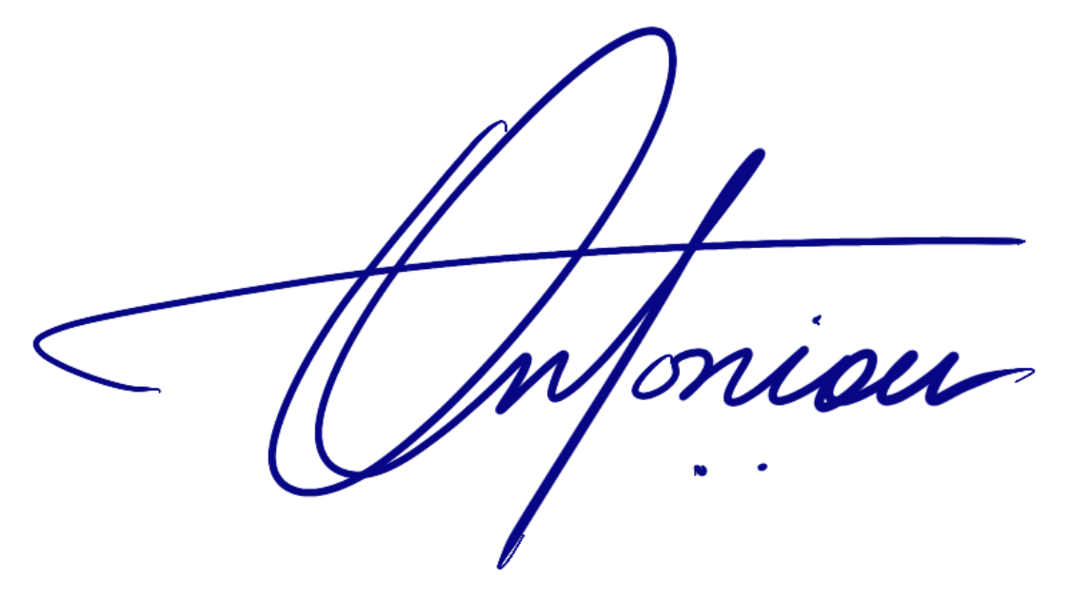
For the Cyprus Third Age Observatory

Demos Antoniou
President

Appendix: Overview of detailed action plan

Policy area | Proposed actions | Timeline
Integration in educational programmes | Development of awareness-raising modules on ageism, integration of ageism in history and literature, creation of interactive learning modules | 12-18 months
Teacher training | Implementing professional development programmes, allocating resources, creating mentoring programmes | 6-12 months
Intergenerational learning | Creating mentoring programmes, developing collaborative projects, organising intergenerational events | 12-18 months
Educational material | Review and revision of material, promotion of positive representations, introduction of literacy programmes in the media | 12-18 months
Public awareness campaigns | Organising public information campaigns in cooperation with the media, actions involving local communities and social media platforms | 12-24 months
Legislative measures | Strengthening anti-discrimination laws, creating reporting mechanisms, promoting age-inclusive policies | 18-24 months
Community programmes | Creating community centres for different generations, developing service initiatives, supporting care and volunteering | 12-24 months
Integration of technology | Implementing digital literacy programmes, creating online intergenerational communities, developing educational technology tools | 18-24 months
Evaluation and monitoring | Establishment of evaluation criteria, continuous improvement, feedback mechanisms, regular review, reporting and accountability | Continuous

The Observatory is a key partner in the European Mentoring Across Borders (MAB) programme, which aims to mentor young people aged 18 to 30 (including those at risk of marginalisation) by professionals/retired people over 50.

